**Chapter 76 – TRIPS, SPECIAL EVENTS, ENTERTAINMENT & REUNIONS**

**Family Camping trips**:

**Fish Lake by Zion’s Canyon** - when we went with our family (Shellie, Roy & family went also). We had never been to Fish Lake, but heard it had beautiful campgrounds and a beautiful lake. It is not the same Fish Lake that we go to now with Sandi & Nick. We didn’t see any campgrounds and ended up in some mountains north of the lake and it was not very pretty and not a good camp site, but we had fun anyway. I don’t think we even went to the lake as we didn’t have a boat at that time. One day we found a skunk in camp, so we all took off for a walk hoping that when we got back, it would be gone. We had mice climbing all over in our tent trailer at night, so that wasn’t fun. Ken and I had to go into the nearest town to get some Decon to kill the mice. We took some of the kids and their spouses in the back of our truck to the narrows at Zion’s Canyon. They had a fun time. We watched the grandchildren. We didn’t have a desire to go to Fish Lake again until Nick wanted us to go there. We are glad he did as we have loved it, it wasn’t the same Fish Lake.

**Betsy Browning, Ken’s nephew, Devin’s wife, loves Family History. She has put in so much time, and has done so much for the Browning lines and her lines. There is a park, west of the train via dock, where she was able to get the original Steven Abiel Browning’s home (Ken’s grandfather) and put it in this park**. She told us about all the interesting things there and how beautiful it is. She takes people on tours there, so we set it up for her to take our family on a tour there. I should have written this down earlier as I don’t remember how many of our family went. It seems like David’s, Scott’s and Jeff’s families went. We went on a Saturday and took our lunch. It was beautiful there with lots of tall trees. There was an Indian village with the teepees and clothes they wore and items they used. I think we all enjoyed the time we spent there.

**Events at Tabernacle and Conference Center in Salt Lake – with Clarks, Roy & Linda, Family**. Our good friends, Green & Kathleen Clark went with us to a Christmas Concert at the Conference Center and afterwards we walked around the temple grounds to see the beautiful Christmas lights. We also did that with Ken’s brother, Roy, and his wife, Linda one year when they were up visiting from California where they live.

**Old Folk’s Sociable** – each March in Grantsville. Sandi & girls usually performed in the programs – dancing (clogging) & Chelci singing**.** They have great programs, dinners, dances & great decorations throughout the high school. Sandi usually had her art work displayed. They also had car shows. We love to go to these.

**Hale’s Theatre** – We had season tickets one year to their plays, plus we have gone other times. For several years we went there to celebrate Ken & Irven’s birthdays (which are only 3 days apart), us two couples would go to dinner and then to a play at Hale’s Theatre

**REUNIONS:**

**Hill Reunions** (Ken’s family) These were usually held in the canyon above Victor, Idaho**.** Each family had their own campsite, but there was a big area with logs around a fire pit where we met for our campfire programs. They usually asked me or Jackie to lead them in some songs and Ken’s mom and her siblings would tell memories of growing up with their parents. Sometimes they had a talent night around the campfire and I remember Uncle Irven & Aunt Bernice doing “Hole in the Bucket, Dear Lisa, Dear Lisa”. They were dressed up in hill billy clothes and Uncle Irven had a bucket with a hole in it. I remember Uncle Albert telling stories. We always enjoyed being together and Ken and his cousins were glad to see each other again as they had grown up together and stayed at each other’s homes during the summers.

**Browning Reunions –** The first Browning reunion that I went to was held shortly after Ken and I were married and was held at the park in Pocatello, Idaho. These first reunions were the Steven Abiel Browning Reunion (Ken’s grandfather, who he never knew in this life, Charles’s father) When we got there, dad Browning’s children, from his first marriage were all there with their families and Cleo came up to me and gave me a hug and said “Welcome to our family, Mae.” He was old enough to be my father, but here he was Ken’s half-brother. Dad Browning’s children from his first marriage are Geneva whose husband was Clyde. Geneva was about the same age as Margaret, Charles’s second wife and Ken’s mother. Cleo was the next oldest and his wife was Norma. Florence, they called her Floss and her husband Keith, and Richard, everyone calls him “Rich” and Lois. Rich and Lois are the ones we have been close with, but the others are all wonderful people who have raised wonderful families. They have all both since passed away, except Lois, as I am writing this in 2013. Anyway, we had a great time getting acquainted. It was just an afternoon reunion. We all brought food and shared it and we took family pictures. Ken’s sister, Margaret, had gone to the restroom at the park and no one realized she was missing when we took the pictures and when she came back and found out we had already taken the pictures without her, she was very upset and went off by herself. Ken’s mom ran to her, but she couldn’t be consoled and thought we had done it on purpose. Why would anyone do that.

We had other Browning Reunions held at the park in Pocatello. I don’t remember a lot about those other than Ken’s second cousin, Kay browning and his wife were there. They are great people and they live in Sunset. He was an Allstate Insurance salesman. .Also, there were those I did know which were Rich, Lois & their family, Roy, Linda & their family, Irven, Sandy & their family and our family.

**Charles Browning Reunions** - We hosted a Browning Reunion at our home when we lived in Firth, Idaho as we had five acres there so there was plenty of room for tents, etc. We played relay games, and other games, had lots of activities for everyone, good food, and lots of visiting. Irven & Sandy hosted one at their home in Goshen also. We didn’t have them for a couple of years and then Irven & Sandy hosted one up a canyon in Salt Lake, I believe. Lots of the family came. That’s the time I mainly grew to know Larry, Ken’s nephew, who is older than Ken. He is Cleo & Norma’s son. Ken said that one time he was with Larry and they ran into Larry’s friends and Larry introduced Ken to them as his “Uncle Ken” and he was much younger and smaller than they were. He said he was embarrassed. Again, we had lots of good food, visiting and evening programs around the campfire.

The next three or more years, the reunions were held at Ken’s niece, Carla and her husband, Craig’s home in Victor as they had a large home with huge lawns. Most of us came on Friday night, stayed the night either in their home or in tents on their lawn and the next day was filled with good food, laughter, visiting, games, etc. It’s always good to be with family. We haven’t had a Browning Reunion since that time. Irven & Sandy were talking to their daughter, Christine, and she knew of an area where we could have one, but she was too busy this year and so were all of us, so we didn’t have one. Linda cornered David this summer and asked if he would head one up. He said everyone would have to help him.

**BUSHNELL REUNIONS:**

My mother was the first of her family to get a reunion going for her parents and Mom’s siblings and their families, a Bushnell Reunion. I remember helping her with it and we held it at the Sunset Park, just below Mom & Dad’s property in Sunset, Utah. The family came on Friday and part stayed with Uncle June & Aunt Marilyn in Bountiful, some stayed with Grandpa and Grandma Bushnell and some stayed at our home. The next day was spent at the park with good food, games and activities and a talent show in the evening. After church we had a great meal and then we had family pictures.

The family decided to hold the reunions every three years. Since Mom is the oldest of Grandpa & Grandma’s children and she held the first reunion, they decided to go to the next oldest, which was Uncle Elmo and his family would do the reunion in three years. It was held in Tropic at the park. Many brought tents and were able to pitch the tents on the lawn at the park. They had a log building at the park and we held some of our activities there. One that this family added was a family auction, where every family was supposed to make at least one or more items to sell at the auction and the money would be used to help with reunions. Koye and Keela helped their parents. We all had lots of fun.

Uncle Van was a professor at the college in Cedar City and the college owned property and a lodge up Cedar Canyon. The faculty were able to reserve it, so that is where we held most of our Bushnell Reunions after that until it was our turn again. Uncle Farrell had passed away and Aunt Joyce, his wife, didn’t want the responsibility of doing a Bushnell Reunion, so it skipped to Aunt Joy and their family held it there at the lodge in Cedar Canyon. Uncle Van’s family was the host family for the next reunion and of course, he held it there. It had plenty of space for RV’s, tent trailers, tents and the lodge had a nice large room with a fireplace, a kitchen, bathrooms and a few bedrooms – some downstairs and some upstairs, so that generation stayed in the lodge. Uncle Van loved a big breakfast with pancakes, bacon, eggs & juice and the lodge had big grills to cook on. We had the same things as the other reunions with the auction, talent show and other activities and good food. I think Uncle Van had some of the meals catered. I know he did at the later reunion they were over and held there. Jeff, Chad & Brady were just little guys at that reunion and we have a cute picture of the three of them together as they came back from climbing partway up the mountain.

Uncle June’s family helped our family put on one reunion and we added colored T shirts. A different color for each family and it said, “Bushnell Reunion” and the date on the back of the shirts. Uncle June’s family was over the T shirts and helped us with other activities, especially the auction. That’s the only reunion I remember Uncle June’s family doing. They were planning on doing one six years ago, but they were going to do it together with Uncle Farrell’s family. Aunt Joyce had passed away and so had Dwaite, their only son, but Pat & Bonnie said they would do it. The two families had problems as Uncle June’s family, Paula & Nancy mainly, wanted to have it in Idaho, but Pat & Bonnie wanted to hold it in Meadow at the park and church there. I guess Paula & Nancy became so upset about it, that they just said to themselves, then let them do it themselves and they didn’t come to the reunion, none of Uncle June’s family did. Uncle June had passed away by this time too. Pat & Bonnie hosted the reunion in Meadow. They had wonderful meals with a big breakfast like Uncle Van and everyone likes. They changed things some, they had Uncle Van take us on a tour to the white sands and the warms springs where Mom and all her siblings were baptized. She had Uncle Van and Aunt Joy tell us about their lives and what they did here in Meadow as they were growing up. They then turned it over to all of us if any of us wanted to tell memories of being with grandpa and grandma.

We did have a wonderful time and they did a great job of hosting it, but we all felt bad about the problem and that Uncle June’s family didn’t attend. I don’t think they attended the one which Keela hosted in 2009 either**, so Uncle Van asked me if our family could host the next reunion and they would do the following one**. He asked me if I would make a special effort to get Uncle June’s family to our reunion including Uncle June children from his first marriage – Danny & Kristy’s family. Danny had passed away recently with a heart attack, so I called his wife, Ann and talked to her. She was nice, but said they wouldn’t be coming. There are problems with that family as Danny & Kristy were not included in Uncle June’s will and Danny was very close to his dad and would visit him often, yet his second wife’s children – Paula & Nancy and his children by his second wife, Steve & Jana, got everything. This was very hard on Danny and also his sister Kristy. They and their families don’t want anything to do with the other family now. I think that is so sad. I don’t know why Uncle June didn’t include Danny & Kristy. I guess Uncle June has had to face Danny now that they are both dead.

Mom was still alive when it was our turn to put on another Bushnell Reunion. We decided to have it up our way since it had been down in Southern Utah for several times. Mom knew a lady who had a ranch up past **Huntsville**. They rented it out for family reunions I helped Mom a lot with this reunion. She got the place and helped me plan some of it, but I was mainly in charge and felt the responsibility of it. Ken, Mom and I went up to the ranch to look at it and I was excited as there was plenty of room for RV’s, trailers, tent trailers, tents, etc. It had a covered cooking area with grills, etc. It had a pond with canoes. It had corrals where we could have a children’s rodeo. They had a large covered pavilion where we ate and visited, and Sandi taught line dancing to most of us and the older ones sat around and watched. It had a huge shade tent where we visited, and had programs. I was able to contact a man who belonged to a group which loved Mountain Men, so they had the costumes, rifles, etc. and he came and demonstrated everything including Indian memorabilia. He told us all about the Mountain Men. He was very good. The couple told us that he could take whoever wanted on a wagon pulled by horses, up the mountain and around the ranch. I contacted all my aunts, uncles & cousins and asked them to write a paragraph or a page telling about their family and send it to me as I was making a book with all this information and I added camp and other old songs for us to sing, histories of Grandpa and Grandma, etc. We did a Dutch Oven Dinner for the Saturday night meal. Sandi was still married to Dave at that time and he is great cooking Dutch oven meals, so he was a big help. Sandi was right there alongside him doing tons too. All our family helped with the meals and other assignments I gave them. I was worried about one main thing and that was if it rained, it would wash out the dirt road leading up to the ranch as it was up a hill. We kept praying for good weather for the reunion and it was. I was very grateful. The reunion was a success and everyone had a great time. I was glad, but relieved that it was over as it had been a lot of work and worry.

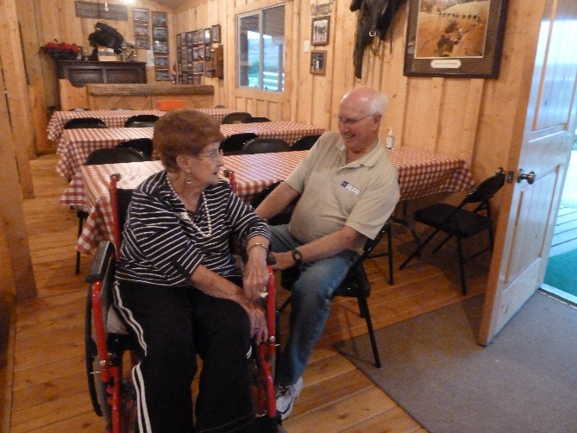**Bushnell Reunion in August of 2009 –** Uncle Van asked Keela if she would host this reunion so since her and Pete own the Trail Canyon Rides into Grand Canyon, Zion’s and Bryce’s Canyon and have land to raise the feed for the horses and mules, she decided to have the reunion on that land. They had built a nice, large barn, cabins and a nice grassy area for volleyball, etc. The barn has a stage and tables all around the outside with chairs, so the chairs can be moved into the center for people when entertainment and programs are being presented on the stage. Keela has decorated the barn so cute with even a buggy hung up above the stage. She has red and white checkered tablecloths on the tables. They have 25 cute log cabins with porches. They built all these as they have people from all around the world come here and stay for a week and each day they take them to different trail rides, then bring them back for wonderful catered dinners and entertainment. She did a great job hosting this reunion and gave family members free rides into Bryce Canyon. She had crafts, games, wonderful meals, etc. We had a wonderful three-day reunion. The only ones from our family who went were Ken and I, Sandi & Nick and David, Shauna and their family. We all had a great time.

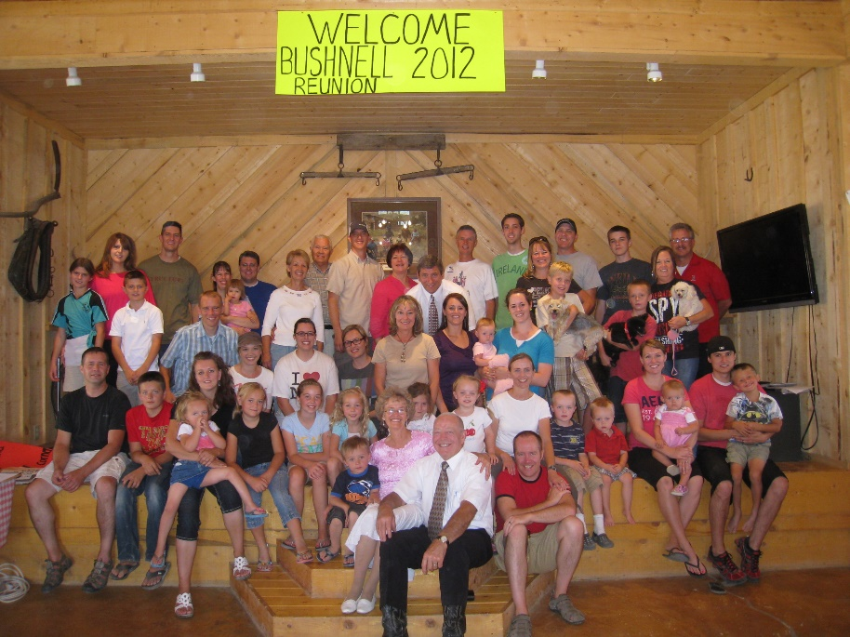**Bushnell Reunion in August of 2012 – The Glendon Porter Family were to host this reunion**, so me and my siblings and spouses were in charge of it. Keela had told me at the last reunion that if we wanted, we could come to Tropic again and have it on her & Pete’s land. I was excited as that is one of the main hard things is finding a place to accommodate that many people. My siblings, spouses, Ken and I get together every three months and have dinner, play games, visit, etc. We take turns hosting it. With this reunion coming up, we spent most of a year planning and preparing for it.

Since I am the oldest, my 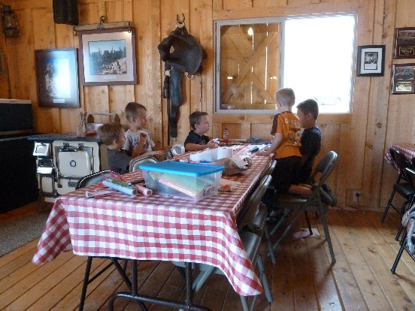siblings expect me to take the lead so I did a lot of planning and making handouts, with my ideas, prior to us getting together for our Siblings & Spouse Get-to-gathers, which we do every three months. We take turns hosting it. After our dinner, we would spend the time making plans for the reunion. They appreciated all the work I had gone to in preparing for it.

I gave them all a category to choose from. Deanna & Bryce choose the children’s activities. Kim & Jeanenne choose the youth & adult activities. Georgia & Rick choose the night activities and Sunday Meeting, and me and Ken had the meals. I asked Terry, who lives in 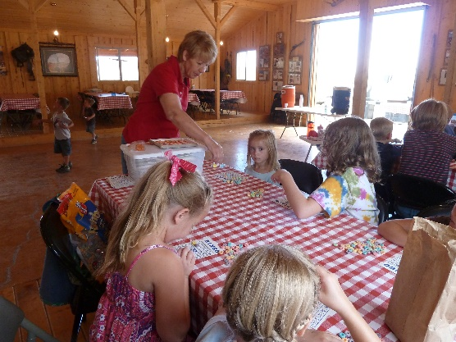Alaska, if he would also help us by getting the e-mail & other addresses and getting the information sent out advertising the reunion and encouraging everyone to come. I got him the addresses that I had. He did a fantastic job and I was sure grateful to him for doing this. Georgia & Rick with the suggestions of all of us choose to have a family dance for Friday night and a Talent night for Saturday night. We all worked hard, and it turned out great. I did a lot of pricing for the foods to get the best deals for the food we would need. So, when we packed up our camper, we went to Costco, Winco, Macey’s, and the Hostess thrift store.

Keela and Crystal (her daughter in charge of the trail rides) still wanted to give the family free three-hour rides into Bryce Canyon, which was special of them. Volleyball was a hit and that was going a lot of the time. The meals turned out great, with all my siblings & spouses helping. I gave them all special assignments. Other family members helped too, which was great!

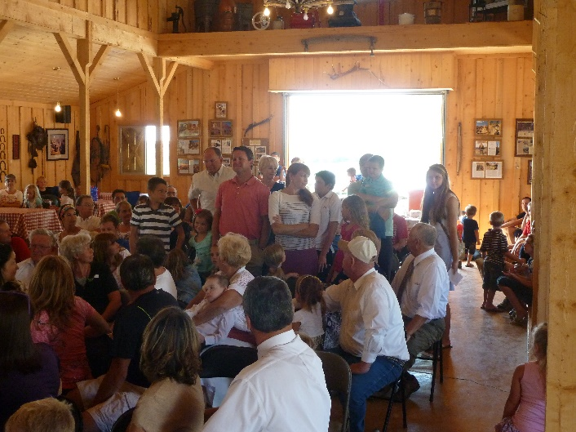We had 150 in attendance. I was praying that it wouldn’t rain during the time of the reunion, and it didn’t. It started raining as we were cleaning and packing up to go home.

We had most of our family come for this reunion, so we had great support. Sandi, Nick and Sandi’s daughters, JaNae, Chelci and their husbands and children came. I think Nick’s son, Logan, came also. Shellie, Roy and Jase came. Quint & Kevis have jobs so they didn’t come. Scott, Mishelle and their children came as well as Jeff, Gail and their children. David, Shauna and their family didn’t come this time as David is doing his internship for medical school. August isn’t a good time for Mike as he is principal of Orem High and he is in meetings usually starting the first of August, so they didn’t come.

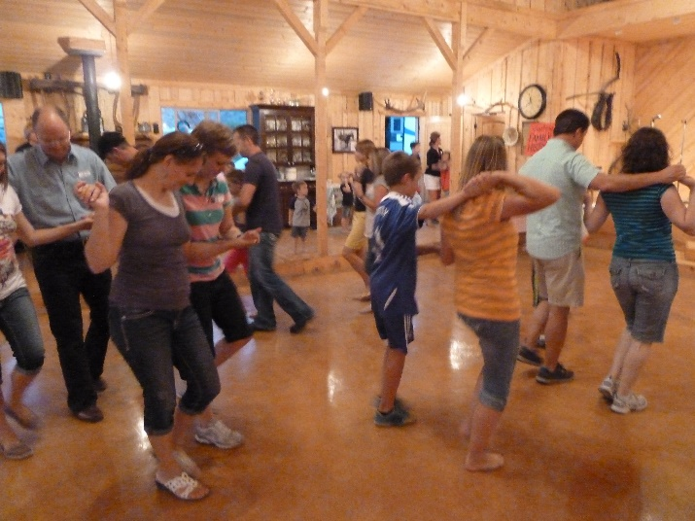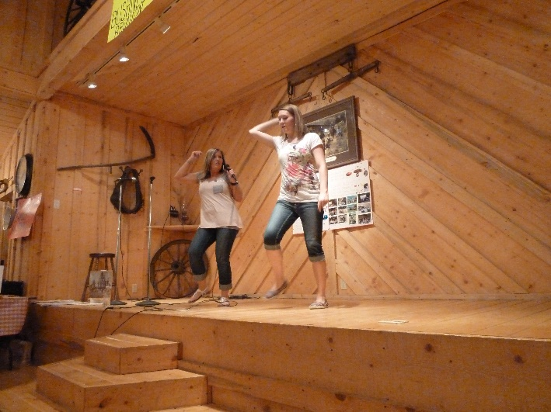

**Sandi and Chelci taught line dancing and those who participated, loved it.**

**Robinson** Reunions in California, Arizona & Idaho. These were large reunions. They were several generation reunions. The main families lived in California, Arizona and Idaho. The first one that I remember going to was held at Max Inn at Island Park. We all camped in the campgrounds or stayed at the Max Inn cabins. Elder LaGrande Richards of the quorum of the twelve apostles is my dad’s second cousin and dad were able to get him to perform Ken & my marriage ceremony at the Salt Lake Temple. He always came to the Robinson Reunions and at the Sunday Meeting, he would always speak. Everyone loved to listen to Elder LaGrande because he told such great stories. In conference, when it was time for the speakers to stop, a little red light would come on, on the pulpit. I remember him saying “I think this little red light is trying to tell me that my time is up, but I have one more story to tell you.” Everyone would laugh, but be excited to hear another of his stories. They were great spiritual experiences. At the close of his talks at the reunions, he would tell us that he didn’t know if he would be around for the next reunion, but he was. He was getting up in years. They had paddle boats which you could rent and use on the river which was close by Max Inn. We didn’t go to the one in California, but we did to the one in Arizona. It was held in the White Mountains area, up where Roy, Shellie’s husband, is from. It is much cooler up there. They had a rodeo, lots of activities, great food. I remember all the good corn on the cob, watermelon, etc. At the last Robinson Reunion that I remember them holding, was held again at Max Inn. We were living with Ken’s Mom in Layton at that time and Shellie was working at Max Inn as a waitress and also in our friend from Firth’s gift shop. She was earning money to go on the “Studies Abroad Program to Israel” which was at the new Jerusalem Center. She was able to go with us to the reunion and again Elder LaGrande spoke and everyone was thankful he was still around to be able to speak to us again.

**Swallow Reunions** held in Meadow **–** I’m not sure how many Swallow Reunions they have held, but the one I remember was after dad had passed away and Mom really wanted to go to see her Aunt Lara and Aunt Noreen and her cousins. These reunions were held in Meadow and dad had passed away, so Bryce and I were able to take her. Georgia and Kim were not able to nor, nor were our spouses, but we had a great time visiting as we drove down and back and it was fun to see how happy it made mom to see her relatives on this side of the family again. We took pictures of her with them. It was just a Saturday Afternoon reunion held at the church. They had a good dinner and program.

**Clark Reunions** – usually held in Farmington, Utah in the old historic rock chapel. It was the first chapel in Farmington when the Clarks, my great, great grandfather, Ezra T and his family settled Farmington. That is the same chapel where the first primary was organized with ???? as the president and my grandmother, Mary Elizabeth Robinson (May) was one of her secretaries. We still have a letter she wrote to May expressing her sympathy when May’s mother passed away. These reunions were well attended, and they had lots of delicious food too and wonderful programs. They were just Saturday afternoon reunions as well. I remember my dad introducing me to his cousins and saying, “This is my daughter, Iva Mae, and she is 40 years old.” After this happening 2 or 3 times, I said to dad “You can introduce me to your relatives, but you don’t have to tell them how old I am.” He replied that I should be thankful that I am as old as I am that he was 71 and he was thankful he was that old.” Now that I am 72, I am thankful that I am as old as I am also.

**Porter Reunions** **(Sanford –** usually in Portervilleat the church and adjoining park there. The first ones I remember going to were great, with lots of people attending. They had wonderful food with Sloppy Joes, chips, lots of corn on the cob, watermelon & cantaloupe, sliced tomatoes, cucumbers and lots of delicious salads and desserts. This reunion seemed to dwindle down until few were coming. My brother, Kim, lives in Morgan and they nominated him for President for the next year. He did and tried hard to get more people coming.

Kim asked me to and Aunt Beth to tell our experiences of writing the Byron Porter books. I did the first one and she did the second one which had more of the Porter ancestors.

He had a 5K run, but few participants. He even went to the work of getting T shirts for each to wear and prizes for the winners. He asked Ken and I and Georgia and Rick to help him by being at different stops along the way to give them cold water and encouragement. We had good food, Jeanenne had made lots of barbecue and they had lots left over. Everyone was to bring salads or desserts. Kim had gotten lots of watermelons. When it came time to nominate a new president for the next reunion, no one would accept the nomination, so they asked Kim to take it another year. He ended up taking it 3 or 4 consecutive years and now they are on their mission so there wasn’t one this year and I doubt if it ever happens again. The older generation has passed away and the young ones don’t know all the people and they don’t want the responsibility of taking it on.

**Byron** **Porter Reunions** held at the West Point Park in early years & later at Layton Park & Surf & Swim

Uncle Dale was the one who first started these reunions and he held them at the West Point Park which was just across the street from his home. It was a Saturday afternoon reunion also. We had good food which everyone helped with. We had a short program, some played volleyball or softball while the younger children played at the playground and the older ones sat in lawn chairs and visited. Uncle Verle and Aunt Beth held these reunions at their home in West Point a couple of times also. They had lots of acreage and a large old home. I remember standing around the piano singing with Georgia and my cousins, mainly girls, while Jeannie, my cousin who is Georgia’s age, played the piano. They had a children’s pool for the young ones to play in, they had volleyball, etc., and lots of good food. Aunt Beth is a great cook and makes lots of yummy desserts. Later, Uncle Dale was able to rent the Layton Pavilion at the Layton Park and the Surf & Swim. He paid for it. We rotated family turns to host it and reserve the Pavilion and Surf & Swim, but the money always came from him and still does even after his death. He told his kids 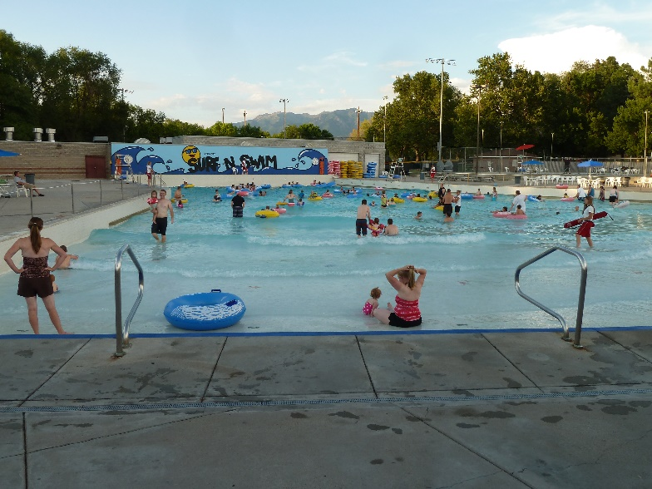that **he would like this reunion to continue here at the Layton Park & Surf & Swim** as we have lots who come even though many of the later generations don’t know each other; they bring their families as they can swim free and have a great meal. Many sat with their parents and grandparents; we do too, but us older generation love to visit with our cousins. We are the older generation now; our parents have all passed away. They were all great people, Grandpa and Grandma Porter raised a wonderful, righteous, humble family. They were all great examples and so were their spouses. Aunt Beth was the last to go, and she was a “jewel”. She was a special aunt and one of Heavenly Father’s choosiest daughters. It was the Glendon Porter Family’s turn to host it when we went on our mission to California, but I was able to arrange with my cousin, Diane, for the checks to reserve the Pavilion and Surf & Swim for that reunion and had Scott take it and reserve it, since he lives in Layton and you have to be a resident of Layton to get it for that price. It is our turn again. Wow! Aunt Merlyn’s family has never taken a turn and her two daughters hardly ever came. LaDean, the oldest, has passed away so there is only Lois. But this next year, it will only be Bryce and I and our spouses and families to do it since Kim and Jeanenne and Georgia & Rick will be on their missions and Terry & Angela are still in Alaska.

**Glendon Porter Reunions** –usually held at **Georgia & Rick’s home**. Georgia & Rick have a beautiful large home with a large back yard. It has playground equipment and a trampoline, not only for their grandchildren, but she taught pre-school for several years and needed these for her students. They also had volleyball standards, net & ball, so they would invite all the Glendon Porter Family one afternoon/evening in the summers. Samantha (Cindy’s daughter) would usually come also. Her adopted father, Bryon Dugan would bring her and they would stay with Georgia and the rest of us for a few days. Now that Samantha is in college, she comes by herself or with her boyfriend. Georgia finally quit having them at her home as the family had grown so large and some of the children were destroying her pre-school equipment or other items, plus tracking dirt throughout the house. She said that after everyone had gone, she would go into her the room where she held her pre-school and it would be a mess. The parents hadn’t checked and had their children clean it up. The same thing was true of the Christmas parties she had for all the family, so they finally discontinued too.

After a couple of years, **I decided we needed to have another one and I had heard of the Heber Valley Campgrounds,** which the church owns. They have it for a Young Women’s camp, but on the weekends, families can reserve it for family reunions. I was able to get it for a Friday night and Saturday. Georgia helped me plan it and we contacted all the family. Bryce & Deanna were on their mission to Spain, but their children acted excited as did everyone else. I did a lot of planning and preparing, Georgia & our husbands helped too and we were disappointed that we didn’t have more come to it. It is a beautiful camp with cabins, large pavilion with lots of tables with benches. There was a room at each side of the pavilion which has shelves, a fridge and grills. They have a campfire area with lots of logs around it, they had a volleyball court and a small lake with paddle boats & canoes on which we could use. They have a camp host who looks after the camp. We had good meals and those who came had a wonderful time. Chad & his wife and some of the others didn’t come up until Saturday afternoon. Nolan & Brandy came Friday night along with some of our family, some of Georgia’s family and I can’t remember whether any more of Bryce’s family or Kim’s family came. I just know that for all the work and worry, I didn’t know whether it was worth it for the few that came. I wasn’t eager to do it again.

**GLENDON PORTER FAMILY REUNION**

**(Same one as above)**

Dear Family, (Year that Bryce & Deanna were on their mission)

Well, the time is about here for our **Glendon Porter Reunion at Heber Valley Campgrounds** on July 27th & 28th. Our campground area is “Sarah, Site 1”. We have 4 cabins in our camp site so room for 64 people. At last count, we will only have 48 at max.

**Mae’s family** - I think we have 20 coming from our family - us, Mike, David & Jeff and families. Scott isn’t sure, but hopefully they can come. From **Bryce’s family**, Nolan and Chad and their families are the only ones able to come.

**Terry’s family** - Meliah and family have been in Alaska with Terry, Angela and their family since the beginning of June, but she was excited about this reunion and didn’t want to miss it so they are flying home on the 266h so they can be with us.

From **Georgia’s family**, they plan on 10 – Georgia & Rick, Kristy, Brian & family and Nathan & Jessica.

**Kim Byron** and Jeanenne will be there with Mysha and Kolessee.

**Facilities** - we have nice restrooms in our camp site with hot water, flushing toilets & showers. We have a nice eating pavilion with tables & benches, grills, fridge, sinks, etc.

**Dinner on Friday night** - we plan to eat our Friday evening meal at 5 pm. Remember, we have asked each family to bring either a salad or desert. If we have leftovers, we can finish them off with our Hogies for our Saturday afternoon meal.

**Campfire program** on Friday night will start at 7 pm - Remember to come prepared to have either a talent from your family or someone to give a memory they have of Grandpa or Grandma Porter or both. The camp site has logs around the fire area, but the adults might want to bring lawn chairs to sit in. We can do some campfire singing also and after the closing prayer, those who want to might stay and roast marshmallows & visit. If you have roasting sticks, bring them.

**Breakfast** - we will have breakfast of pancakes, bacon, eggs, juice & milk at 10 am. Since we have to be out by 5 pm, we felt it would be best to have a late breakfast and an early dinner at 3:00 pm. If your children will have trouble waiting until 10, you might want to bring them something to tide them over.

**Dinner** - we will have Hogies, chips, veggie trays & leftover salads, deserts & watermelon for our 3 pm meal.

**Activities** – they have a volleyball court in our area. We will have games for the younger children and some board & card games for youth & adults. The camp also does challenge courses. You could make reservations for these in advance.

**Cost** – the cost for the camp site was $160.00 so it will cost each family $12.00. We don’t have the cost of the food yet, but it shouldn’t be too expensive since we are having simple meals and you are bringing salads & deserts.

**Drinks & snacks** – If you want additional drinks or snacks for your family, feel free to bring them.

**Directions** to Heber Valley Campgrounds & Sarah, Site #1 – I am enclosing the map & directions.

Well, that is all I can think of, but if you have other questions you can respond back to this e-mail or call me at 801-825-5112 or my cell phone is 801-499-6986 & Ken’s is 499-6987, or you can visit the web site at [www.hebervalleycamp.org](http://www.hebervalleycamp.org)

With Love,

Mae

We didn’t have as many come, as we had hoped for and some came and went or came really late, so I was discouraged as I had gone to a lot of work in planning and preparing for this reunion. I haven’t been excited to do it again.

**Ken and I held a Glendon Porter Family Reunion in our big backyard in Clinton in September of 2012**. Everyone thought I was crazy to do it especially since we had been so busy with the Bushnell Reunion and had just held it in August, but this was just an afternoon/evening reunion, so it wasn’t very hard. We put up our big shad tent and we had everyone bring their own meat to grill and then a salad, dessert or vegetable or fruit tray. We played volleyball, corn hole, some of the children played on our playground plane or tree swing and some went over to the park. We enjoyed visiting and being together. It turned out great!

**A couple of years ago, probably 2016, I tried it again, and reserved a pavilion at a Roy Park near us**, and asked everyone to bring “Pot Luck”. It turned out fine, but we didn’t have many come, so I haven’t felt like doing it again. It seems everyone is “too busy” anymore doing their own family activities, sports for their children, etc. It’s kind of sad.

**I do feel it’s important for us to keep the one on the Saturday before Memorial Day** going, as it’s been a tradition as long as I can remember. We meet at the Morgan Cemetery at 3 pm. We decorate the graves, visit and take pictures. We try to show the grave stones of my parents, 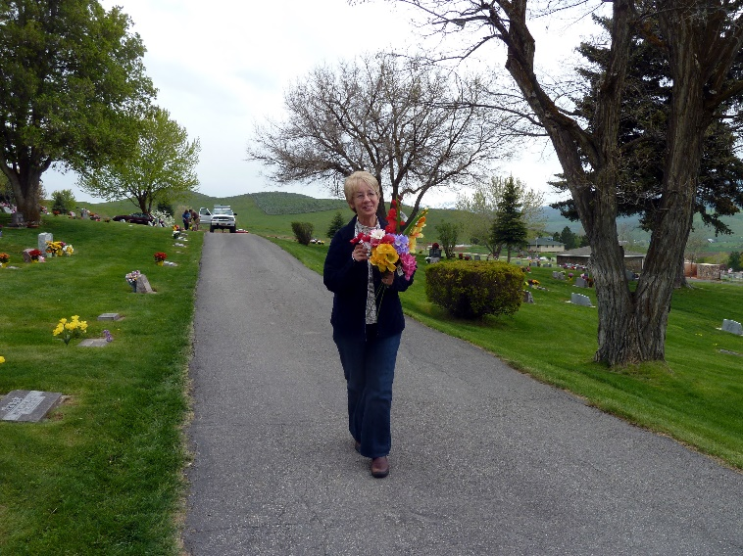grandparents, aunt, uncle, brother, sister-in-law and niece, to the grandchildren and great grandchildren so they will remember them as we explain who they are and somethings about them. We then go to the Morgan park, where we reserve a pavilion and eat dinner. We all bring our own food, so that makes it easier, many just stop and buy chicken or fast food to eat there. The children play on the water splash pad or on the playground, the boys, and some girls, and their fathers usually play volleyball and lawn games. Most of us ladies just sit and visit with each other. Many usually come to this and I am happy about that. I remind them at least a month ahead, so they can plan on it.

**PORTER COUSIN’S REUNIONS**

I started these and held the first one at our stake center in Clinton. Ken and I, with the help of my siblings, set up round tables all around the cultural hall. We all brought “Pot Luck” items and it turned out great. After eating and visiting, we had those who wanted to, to stand and tell about their experiences with life and about their families. Uncle Wayne and also Aunt Beth were still alive at that time, their spouses had passed away, but they came with their children and we were happy to visit with them and all the cousins and get caught up on our lives. We had a great turnout and we all had a wonderful time.

From them on, Lail and her husband hosted it at their beautiful home. They live up on top on a hill and have a beautiful yard and view from the front. They have plenty of parking. We usually have it in May and if the weather is good, they have tables set outside where we eat. We all bring “Pot Luck” items for the food and it is always delicious and we have plenty. We visit and then usually go inside and we take turns telling about what has gone on in our lives, since last we met. It is especially great to hear about those who have returned from missions. Last May (2019), Lail heard me telling Deanna about Grandpa and Grandma Porter, so she asked if I would tell all of them about these special grandparents. Georgia, Bryce, Kim, John, Lynn and those who knew Grandpa and Grandma shared their experiences also. Many were too young and couldn’t remember much about them. We all enjoy being together. These are wonderful cousins (spouses too).

**Randy is blind**, so it’s hard for him and Judy to come, but he does when he can, and when Judy can’t come, Kevin brings him. Ken and I have had a great relationship with Randy and Judy. We have gone camping in their RV and fishing at East Canyon Reservoir together. Randy was trained in Massage therapy and deep Trigger, so Ken and I would get treatments from him. He had a nice building in back of their home and he had it all set up with his table, and whatever he needed, plus a nice bathroom and bedroom, where he could rest afterwards as it took a lot out of him. Randy loves to fish, even though he can’t see the fish, so Ken has taken him fishing both in our boat and in Randy’s boat. Ken has to do everything, including baiting Randy’s hook and taking off his fish. It is a lot of work for Ken, but he loves Randy and is happy to do it for him. They have a good time visiting and have a great relationship**. Today, July 12, 2019, Ken went down to Randy’s in West Point, and took him to Layton where they got a frozen yogurt, and could spend time visiting**. He just called and said he would be longer as Randy asked him to take his boat to a boat shop to have it worked on. I’m glad Ken is so good to Randy as Randy has a hard life with not just being blind, but has had terrible accidents, which almost cost him his life and so he is in terrible constant pain. It’s hard for him to enjoy his family as the noise bothers him and he trips over the toys they are playing with. Judy does enjoy her family, so does a lot for and with them, and tends the grandchildren a lot. She has been the ward Relief Society President also, so leads a busy life.

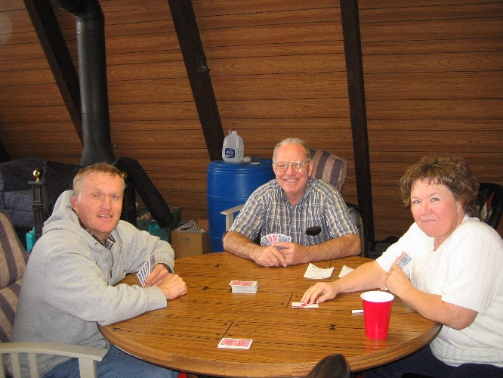Randy had a large room build for him on the side of their home. He has an outside door and a door going into the rest of the home. He calls it his “Man Cave”. He stays in there a lot. He has a fridge, his computer, which is voice activated, his bed, bathroom, exercise equipment, etc., etc. He is a good man, but I’m sure it is so hard on both him and Judy. Judy has to take him everywhere. When they married, they had no idea he would go bling. Judy waited for him when he went on his mission. His dad divided up his business with his kids. Randy finally had to sell his part when his eyesight went, but he was pretty well set up financially, so that’s a good thing. **They have a cabin up in the Unitas**, which they like to go to in the summers, so that’s good. Randy used to hire Ken to fix things at his cabin and reroof it one time, so we have been there a few times also. Before he became totally blind, he could play cards. He bought large cards with large numbers and could see them faintly. Now he can’t. He had seeing-eye dogs at different times. The first one was great, but got run over by a neighbor accidently. The other dogs haven’t worked out for him.

**At a previous Bushnell Reunion,** Joyce and I talked about how it is hard for many of our children to come that far to Tropic for this reunion, especially those who are out of state. Some don’t want to come as it is our cousins and their families, and they don’t know them or care to know them. The cousins all met and discussed continuing these reunions. Joyce and I were outvoted, most wanted to continue them. .I suggested we have a “**Bushnell Cousins Reunion**” instead and take turns hosting it. They thought that was a good idea, but wanted both. I had told them about the Porter Cousin’s Reunion, and since it was my idea, they asked if I would host the first one. I agreed. We were going to have one every other year, since many come a long way. I reserved our stake center and ordered food from a caterer, who our ward had used several times. Aunt Joy passed away just a few days before this reunion was to happen, and since all the cousins wanted to attend her funeral, they felt it would be too much to make another trip that soon. We did all go to Aunt Joy’s funeral, and did some visiting there while we ate the lunch the ward relief society had prepared for us. Since it was too late to cancel the food I had ordered from the caterer, my siblings and our spouses decided that we would all come and share in the expenses and divide what was left to take home. I had told the caterer how many would attend, when I thought all my cousins and spouses were coming, but I was glad they didn’t come, as there would not have been enough food for all of us. I don’t know what the caterers were thinking, but we didn’t have much at all left after we had eaten. I didn’t feel like hosting another Bushnell Cousin’s Reunion, and no one else hosted it. Oh well, that might have been too much since we all live far apart.

Ken and I also hosted the **Charles Browning Reunions** a couple of times. One was in our back yard in Clinton. Most of Ken’s siblings and their families came, even Doug, Karen and their family who live out of state. We all had a great time. Shellie and family were up too and she hardly even gets to be with her cousins, so she was happy to see and visit with them, as we all were. We ate good food, which everyone helped with, some played volleyball and lawn games and lots of us just sat around and visited.

K**en and I hosted another one at a park here in Roy for an afternoon and evening.** Cheryl & Bob Bottom and their grandchildren came, Bruce and some of his family came. Shellie & Jase were here, so they came with us, although I think she was the only one from our family who came. Irven, Sandy and some of their family came. There were not too many, but we had a good time anyway.

**Three years ago, Jennifer and Irven and Sandy’s family hosted a Charles Browning Reunion** and we had many who attended. It was at a girl’s camp up in the mountains east of Paradise, in Cash County. The road going up to the campground was treacherous, especially if you had to pass a vehicle coming the other way. Sandi and Gary had some damage to their toy hauler because of that. I think others did also. It was beautiful up there and we had great food, fun games and lots of visiting. Even some extended Browning members came. I think we brought Bob with us. Carroll had already passed away.

**Ken and I hosted a Leo Jensen/Charles Browning reunion**. We held it at a campground in the mountains, up in Cash Valley. Many of Dad Jensen’s family came and many of the Charles Browning family came. It was fun getting to know Dad Jensen’s family better. We ate, played volleyball and mainly visited. The children had fun exploring around and playing together.